UPCOMING CONVENTION ATTENDANCE PROFILE
Golf Course Superintendents Association of America

Saturday, February 5 – Thursday, February 10, 2022

Anticipated Attendance 12,000
Group Description
GCSAA is dedicating to serving its members, advancing their profession and enhancing the enjoyment, growth and vitality of the game of golf. The golf course superintendent is the manager of the game’s most valuable resource: the golf course. The career is multi-faceted. It involves turfgrass management, environmental stewardship, research, personnel management, budget development, accounting, event management, inventory control, communications and a variety of other tasks. Above all, superintendents either love golf, love to work outside or both!

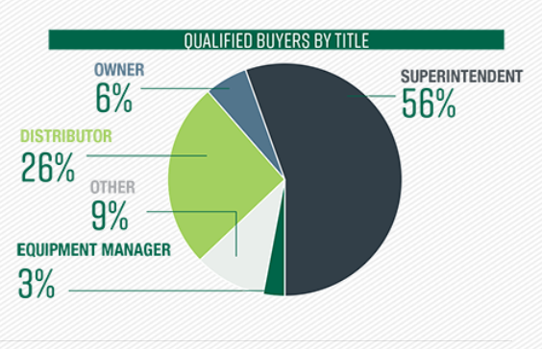
Attendee Profile
More than 6,000 qualified buyers from over 60 countries will be in attendance. You will reach the entire course, club and facility management audience.

Room Block

Day/Date | Guestroom Block
Saturday, February | 492
Sunday, February | 1,722
Monday, February | 3,690
Tuesday, February | 4,920
Wednesday, February | 4,920
Thursday, February | 3,690
Friday, February | 738

Hotel | Guestrooms Blocked
Marriott Marquis | 1,100
Grand Hyatt | 500
Hilton San Diego Bayfront | 600
Courtyard San Diego Gaslamp/Convention Center | 65
Embassy Suites | 150
Hard Rock Hotel | 230
Hilton Gaslamp Quarter | 170
Horton Grand Hotel | 80
Hotel Solamar | 100
InterContinental | 100
Omni San Diego Hotel | 400
Residence Inn San Diego Downtown/Gaslamp Quarter | 100
Marriott Gaslamp Quarter | 150
The US Grant | 75
Westin Gaslamp Quarter | 200
Wyndham San Diego Bayside | 303

Schedule of Events
Date | Sat., 2/5 | Sun., 2/6 | Mon., 2/7
Approximate  Attendee  Arrival | Approx. 1,200 attendees | + 3,000 attendees arrive  (4,200 total) | + 4,800 attendees arrive  (9,000 total)
Convention Center Activity & Meals | Golf Championships  Day One  (Torrey Pines, Singing Hills Golf Resort, Bernardo Heights Country Club) | Golf Championships  Day Two | Golf Championships  Day Three  Various Tours  6:30pm-9:30pm  Welcome Reception on the Midway Aircraft Carrier Museum
Attendee Open Meals | On own for all meals. | On own for all meals. | Breakfast and Lunch on own.

Date | Tues., 2/8 | Wed., 2/9 | Thurs., 2/10
Approximate  Attendee  Arrival | + 3,000 attendees arrive  (12,000 total) | (12,000 total) | - 3,000 attendees depart  (9,000 total)
Convention Center Activity & Meals | Opening Session  Seminars  Trade Show | Seminars  Trade Show | Seminars  Trade Show  Closing Celebration  5:30pm-7:30pm
Attendee Open Meals | On own for all meals. | On own for all meals. | On own for all meals.

Off-Site Scheduled Events
Saturday, 2/5-Monday, 2/7 Golf Championships at Torrey Pines, Singing Hills Golf Resort, and Bernardo Heights Country Club.

Monday, 2/7 various tours around the city. Welcome Reception aboard the USS Midway Aircraft Carrier Museum from 6:30pm-9:30pm.

Shuttle Information
No shuttle provided.

Contact Information
- Maria Andriola, National Sales Director, SDTA
- Gerrica Gray, Senior Convention Services Manager, SDTA
- Jana Brown, Director, Conference Events and Meeting Planning, GCSAA

